
Please download the pdf document in the resources section to view the emails you will need to investigate.

In your investigation of the emails, what signs did you find to indicate whether each email was malicious or safe? Give your opinion and analysis on these emails in this document, then upload it as your submission.

Here is an example to use as a reference point:
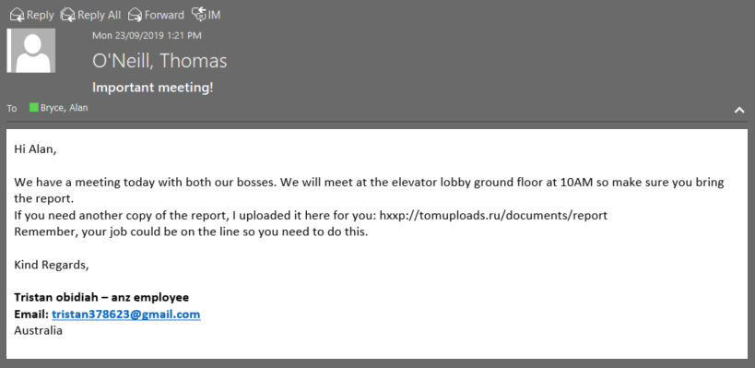

Example Answer (Please note this is not part of the Task and is an example only. Please remove this section from your task submission):

Is this email Safe or Malicious? | My Analysis
Malicious | - The attached URL is from Russia.  - The email sender is requesting the user download a file with fairly generic justification.  - This is enough indicators for us to assume that the link is probably malicious and should be treated as such.  - Overall the email is not very professional. It is far too generic using terms that could apply to almost anyone and anywhere such as “the report” and the job title of “anz employee”. Also ‘anz’ is not capitalized, and the email provided is not a business email.  - The name the email uses isn’t consistent with the display name.  - Finally the email tries to instill a sense of urgency and dread by mentioning that the person’s job is on the line, and mentioning their bosses to provide some sort of authority to what they are saying. This is a common form of social engineering.

Email 1:

Is this email Safe or Malicious? | My Analysis
Safe | - Casual talk between two friends  - .Time difference is two minutes, We could assume that this mail was being waited for.

Email 2:

Is this email Safe or Malicious? | My Analysis
Malicious | - No organization ever tells you to update your profile to get new perks  - Security is written in capitals; No proper formatting in the email  - Adobe always has a certain file limit range. There could never be a email regarding getting large files update.

Email 3:

Is this email Safe or Malicious? | My Analysis
Malicious | - One of the vague mails and easiest to identify  - Facebook never asks whether your account is working or not  - Some user or a friend is sending the mail that there account is not working which is actually phishing

Email 4:

Is this email Safe or Malicious? | My Analysis
Safe | - This email is one of those emails which actually seems like real  - They are having the link which certainly would lead to their website and the product  - Also no vague talks; legit product description  - If it has to be a malicious email, this is only due to fact that the email id of this forwarded mail does not seem to be real

Email 5:

Is this email Safe or Malicious? | My Analysis
Malicious | - Again the easiest ones to detect that this is a fraud email  - No government specially undercover agents would ever mail you to ask if they could send a email  - This is so practical; It would be against their privacy as well  - 100% fraud email

Email 6:

Is this email Safe or Malicious? | My Analysis
Safe | - This seems to be a safe mail as there is a proper footer in it.  - It seems like a mail service usage inside the organization  - ANZ mail ids are being used which is not received by everyone until you are a part of ANZ  - This is a casual mail between two colleagues just randomly talking about important stuff as well casual things at the same time

Email 7:

Is this email Safe or Malicious? | My Analysis
Malicious | - 100% malcious  - Only a link is given  - No proper formatting  - Username of the sender is very vague  - PHP files are always dangerous as they could have a attachment attached in it very easily.  - HTTP link which is not safe

